Track Name
Track 1 - Game (Pygame)

Project Title
Maze Runner

Course Name: Programming in Python

Faculty Name: Md. Tanzeem Rahat

Student Name: A.S.M. Mahmudul Hasan

Student ID: 21-45488-3

Section: C

Semester: Spring 25-26

Project Overview:
This project is a maze escape game developed in Python using the Pygame library.
The main goal of the game is to move through the maze, collect the key, avoid enemies and traps, and reach the exit door before the timer reaches zero. It also includes data persistence using JSON files for top 10 scores and saved settings.
Objective of the Game
The player must:
1. Start from the player position
2. Move through the maze
3. Collect the key
4. Avoid traps and enemy contact
5. Optionally collect bonus items
6. Reach the exit door before time runs out
Win Condition:
The player wins a level by:
- collecting the key
- then reaching the exit door
The player completes the full game by clearing all levels.
Lose Condition:
The player loses if:
- the timer reaches zero
- all lives are lost after touching enemies or traps
External Library Used:
- `pygame`

Setup & Run Instructions:
Environment Setup:
Step1: Create venv environment: py -m venv .venv or python3 -m venv .venv
Step2: Activate venv environment:
Windows: .venv\Scripts\activate
MacOS/Linux: source .venv/bin/activate
Step3: Install dependencies: python -m pip install -r requirements.txt
Step 4: Run the application: python main.py

Features Implemented:
- Player movement
- Maze wall collision
- Key collection
- Exit door
- Enemy movement
- Smart chasing enemy option
- Trap collision
- Bonus collectible item
- Timer system
- Score system
- Time bonus
- Lives system
- Level progression
- Start menu
- Top 10 score screen
- Settings screen
- Top 10 score saving
- Settings saving
- Restart system
- Exit system
- Health/lives system
- Settings save
- Collectible bonus items
- Enemy with smarter chasing behavior
- Top 10 score saving instead of only 1 high score
- Player and enemy images
Data Persistence
The project saves data in JSON files.
data/highscore.json
Stores the top 10 scores.
data/settings.json
Stores:
- smart enemy enabled/disabled
- show hints enabled/disabled
- starting lives

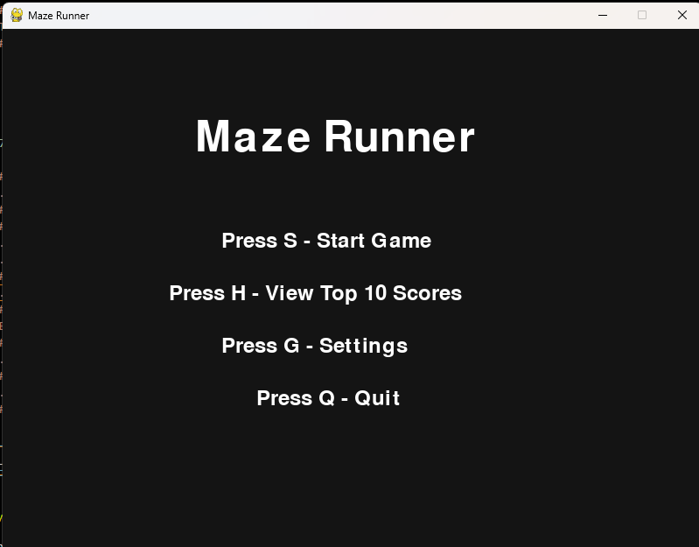Start menu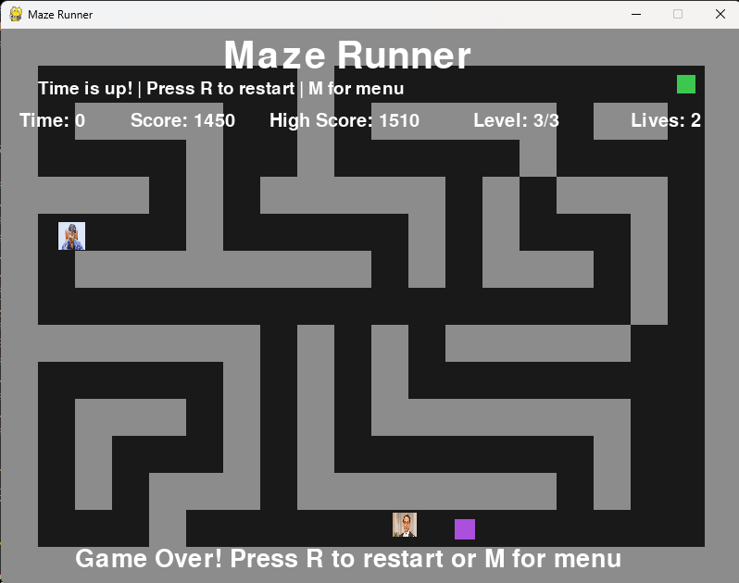
Gameplay screen
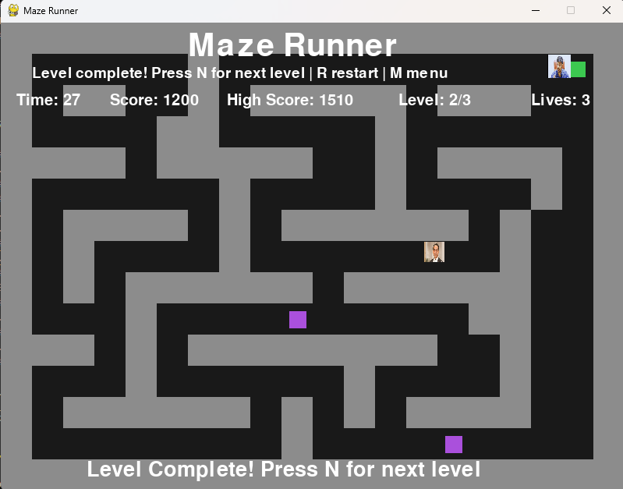
Level Complete Massage
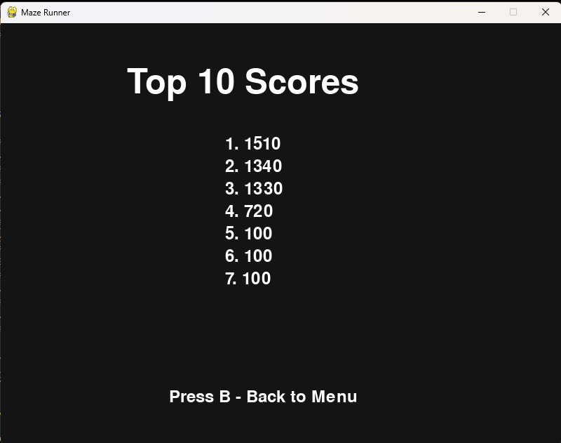Top 10 score screen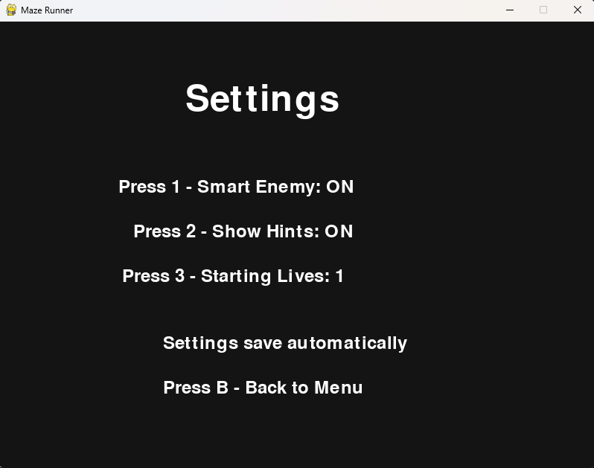
Settings screen

